A Project Report

On

**Online Quiz Application**

In partial Fulfillment of the requirements

For the degree of

**BACHELOR OF TECHNOLOGY**

In

**COMPUTER SCIENCE AND ENGINEERING**

Submitted by

**Kapil Kumar (2004790100020)**

**Mahak Alvi (2004790100023)**

**Jugendra (2004790100017)**

**Prasang Kumar (2004790100035)**

Under Supervision of

**Mr. Ashish Saxena**

**(Assistant Professor)**



**Department of Computer Science and Engineering**

**Rajshree Institute of Management and Technology, Bareilly**

**Dr.A.P.J Abdul Kalam Technical University, Lucknow**

**(2023-24)**

**DECLARATION**

I hereby declare that this submission is my own work and that, to the best of my knowledge and belief, it contains no material previously published or written by another person nor material which to a substantial extent has been accepted for the award of any other degree or diploma of the university or other institute of higher learning, except where due acknowledgment has been made in the text.

|  |  |  |  |
| --- | --- | --- | --- |
| Signature : |  | Signature : |  |
| Name: | **Kapil Kumar** | Name : | **Mahak Alvi** |
| Roll No : | 2004790100020 | Roll No : | 2004790100023 |
| Date : |  | Date : |  |
|  |  |  |  |
| Signature : |  | Signature : |  |
| Name : | **Prasang Kumar** | Name : | **Jugendra** |
| Roll No : | 2004790100035 | Roll No : | 2004790100017 |
| Date : |  | Date : |  |

**CERTIFICATE**

This is to certify that the Project Report entitled **“Online Quiz Application”** which is submitted by **Kapil Kumar** (2004790100020), **Mahak Alvi** (2004790100023), **Jugendra** (2004790100017), and **Prasang Kumar** (2004790100035) is a record of the candidates own work carried out by them under my supervision. The matter embodied in this work is original and has not been submitted for the award of any other work or degree.

**Mohd. Arif Mr.Ashish Saxena**

H.O.D(CSE) Supervisior

**ACKNOWLEDGEMENT**

I have taken efforts in this project. However, it would not have been possible without the kind support and help of many individuals and organizations. I would like to extend our sincere thanks to all of them

.

I am highly indebted to **Prof. Ashish Saxena** for his guidance and constant supervision as well as for providing necessary information regarding the project and also for their support in completing the project.

|  |  |  |  |
| --- | --- | --- | --- |
| Signature : |  | Signature : |  |
| Name: | Kapil Kumar | Name : | Mahak Alvi |
| Roll No : | 2004790100020 | Roll No : | 2004790100023 |
| Date : |  | Date : |  |
|  |  |  |  |
| Signature : |  | Signature : |  |
| Name : | Prasang Kumar | Name : | Jugendra |
| Roll No : | 2004790100035 | Roll No : | 2004790100017 |
| Date : |  | Date : |  |

I would like to express our gratitude towards our parents and members of **Rajshree Institute of Management and Technology Bareilly** for their kind cooperation and encouragement which helped me in completion of this project.

**Abstract**

The project: “Online Quiz Application” is a collection of number of different types of quizzes like technical, games, sports, etc. A user can access/play all of the quiz and can attempt any of the one. There will be limited number of questions and for each correct answer user will get a credit score. User can see answers, upload questions etc. There are many quiz applications available currently on internet. But there are few Which provide better understanding between users and the application like, providing proper answers, uploading user questions as well as answer to it, etc. To develop a user friendly quiz application which will contain : Numbers of quiz , Answers to every question, Uploading of user question and answer, and to improve the knowledge level of users. To develop an application which will contains solutions to the above problems. By this application the user will come to know about his/her level and can learn additional knowledge. Also by this application a user can expand his/her knowledge among the world. Here user can be a teachers, students and other like admin. This quiz application can provides a significant help in running a weekly or monthly quiz programs for an educational institute.

**List of Figures**

|  |  |  |
| --- | --- | --- |
| **S.No.** | **Figures** | **Page No.** |
| 1 | SDLC Diagram of Project | 11 |
| 2 | Data Flow Diagram | 14 |
| 3 | Use Case Diagram | 15 |
| 4 | Home Page | 15 |
| 5 | Login Page of Admin | 16 |
| 6 | Login Page of Teacher | 16 |
| 7 | Login Page of Student | 17 |
| 8 | Admin Dashboard | 17 |
| 9 | Teacher Dashboard | 18 |
| 10 | Student Dashboard | 18 |
| 11 | Teacher Page | 19 |
| 12 | Student Page | 19 |
| 13 | Add Course | 20 |
| 14 | View Courses | 20 |
| 15 | Add Questions | 21 |
| 16 | View Exams | 21 |
| 17 | Rules of Exam | 22 |
| 18 | View Marks | 22 |
| 19 | Logout Page | 23 |
| 20 | Testing Process | 24 |

**Table of Contents**

|  |  |
| --- | --- |
| **Topics** | **Page No.** |
| 1.Introduction | 8 |
| 1.1 Existing system | 8 |
| 1.2 Project Objectives | 9 |
| 1.3 Problem statement | 9 |
| 2. Literature Review | 9 |
| 3. Methodology | 10 |
| 4. Project Requirements | 11 |
| 4.1 Project Requirements Specification | 11 |
| 4.2 Hardware Requirements | 11 |
| 4.3 Software Requirements | 12 |
| 4.4 Implementation Constraints | 12 |
| 5. Basic Concepts and Tools | 12 |
| 5.1 Python Introduction | 12 |
| 5.2 Django Introduction | 13 |
| 5.3 VS Code | 13 |
| 5.4 Sqlite Introduction | 13 |
| 6. Diagrams | 14 |
| 6.1 Data Flow Diagram | 14 |
| 6.2 Use Case Diagram | 15 |
| 7. Modules of Project | 15 |
| 7.1 Home Page | 15 |
| 7.2 Login Page | 16 |
| 7.3 Admin Dashboard | 17 |
| 7.4 Teacher Dashboard | 18 |
| 7.5 Student Dashboard | 18 |
| 7.6 Teacher Page | 19 |
| 7.7 Student Page | 19 |
| 7.8 Courses Page | 20 |
| 7.9 Exam Page | 21 |
| 7.10 Marks Page | 22 |
| 7.11 Logout Page | 23 |
| 8. Testing | 23 |
| 8.1 Objectives | 23 |
| 8.2 Process Overview | 23 |
| 8.3 Testing Process | 24 |
| 8.4 Testing Strategy | 25 |
| 9. User Manual | 25 |
| 9.1 Purpose | 25 |
| 9.2 User Manual for the Developers | 25 |
| 10. Drawbacks and Limitations | 26 |
| 10.1 Proposed Enhancements | 26 |
| 11. Conclusion | 27 |
| 12. References | 28 |

**Introduction**

The ‘Online Quiz Application’ project will be developed to overcome the time consuming problem of manual system. Apart from that in current system, checking the answer sheets after taking test, waste the examiners time, so this application will check the correct answer and save the examiner time and carry the examination in an effective manner. The users which are use this system don’t need to high computing knowledge and also system will inform them while entering invalid data.

The aim of this project is to computerized the existing manual system and help the examiners to save their valuable time and important data. Apart from this, data which are exist in this system, will exist for long period of time and will be easy accessible. This project helps the examiners to manage their services in a good way and provide a better service to their users.

The objective of this project is to manage the details of students, examinations, marks, courses and papers in a good manner. The performance of the application will be fully control by administrator and administrator can guaranty any one to access. The project will reduce the manual process in managing examinations and all issues regarding that.

To design and implement this project we plan that the project support to different types of users apart from its administrative part. When project is run for the first time it allowed the user to select as who he/she wants to login in the system. Project support login as teacher and login as student. If a user who is student, try to login as teacher system will not allow him and vice versa. User who add as teacher in system will be able to punch test and questions to system and also will be able to observe the result of the student which attempt tests. User who login to system as student will be able to select a particular test and attempt questions depend on this test. After attempting the test and submitting that user will receive a message that you have attempt the test successfully and if the user tries to attempt the same test, system will not allow him/her. Also a user which login to system as student will be not able to observe the result of test he/she attempt.

**Existing Systems**

There are various MCQ quiz applications exist in the internet with different criteria. Each of the existing applications has their own goodness and problems. In this MCQ quiz application which is designed and implemented in Python based we try to overcome the existing problems with following features:

* Remove source confuse issue
* Better management
* Connection to database for better storing of data
* Better frontend management
* Better backend management
* Try to decrease error issuer during runtime.

**Project Objectives**

The main objective of the project MCQ Quiz Application is to manage the details of students, examinations, marks, courses and papers. The project is totally at administrative end and thus only the administrator is granted the access. The purpose of the project is to build an application to reduce the manual work for managing the MCQ quiz and we will follow to achieve these objectives in this project

* Able the examiners to punch the MCQ questions online.
* Able the users to solve the questions online
* Examine
* rs can manage the information regarding exam
* Correct answers will be evaluated by system (First it should be determining by examine)
* To create an appropriate platform for best managing of MCQ test
* To overcome the time consuming issues and taking MCQ tests
* To release the marks of the test taker as soon as possible
* To manage the information of different tests.er);

**Problem Statement**

In this quiz application which is designed and implemented in Python we try to overcome the existing problems with following features

* To Remove source confuse issue
* For Better management
* For Connection to database for better storing of data
* To Better frontend management
* To Better backend management
* To Try to decrease error issuer during runtime.

**Literature Review**

Literature Survey for problem identification and specification Viska Mutiawani ,Najmuddin Amrin, Kurnia Saputra, Dalila Husna Yunardi Informatics Department from Syiah Kuala University Banda Aceh, Indonesia. In this case, the researchers conducted a survey for 20 students of the Informatics Department class of 2015 randomly. The question is, ”Have you ever experienced a failure to answer the quiz, as a result of an internet connection?”. From the results of a survey of 20 students, the researchers found that 15 of them answered that they had. Based on this simple survey, the researchers can conclude that the opportunity for 20 students of the Informatics Department class of 2015 who have experienced failure while taking the quiz is 75%. This shows that the chance of failure is quite often, but this survey is just a preliminary survey that has not been able to represent the true probability of failure. Adarrsh Paul, Rajat Kumar Singh, Jayant Singh,Tulasi Sai Shweta U.G. Scholar, Computer Science & Engineering, SRM University, Tamil Naidu, India. The Quiz App is rated in the top 5 aptitude applications in android market developed by Sindu Rajan and designed by Yalini Kumaraguru. Pocket Aptitude is a collection of 10+ quantitative aptitude questions and word problems frequently asked in competitive examinations and placement papers. It is designed as a preparation tool for job aspirants and those waiting to crack CAT, NTSE and various bank exams. People with an inclination towards mathematics can use this app to sharpen their IQ, test their aptitude skills and enrich their knowledge. This application has various fine points and flaws provides good user interface but only for practice test but the questions being asked are of old pattern and not in trend. The main moto is to make this app work faster and efficient enough for students to make most out of it. The Logical Reasoning and Aptitude application developed by team is also popularly used aptitude test application. Logical Reasoning helps in improving problem-solving skills by focusing on Logical Reasoning Questions. Logical Reasoning will help you in preparation of admissions tests and other different kind of exams, but the user interface is not interactive, the user has to scroll horizontally to view the entire answer. It just has MCQ’s for test and score evaluation.

Vaibhavi Balaji Kunale, SharvariSandiip Shinde, Shelke R.B Student, Department of Computer Engineering, MM Polytechnic, Pune, Maharashtra, India Android is rapidly getting famous, and therefore the number of its users are increasing day by day, because it's easy to access the required Android-based apps on tablets and smartphones. Therefore, we found the use of the Android App is less complicated and longer efficient to facilitate the users during this way with none difficulty. Applications and widgets Application Programming Interface Libraries Android runtime Android Architecture reduces the time of development and can reduce the quantity of memory that is required by the appliance. In Future we are able to include redesigned an friendlier user interface because the application targets various levels of users starting from sophisticated programmer to naive users Android is most used Mobile OS worldwide. making an android app isn't as difficult mutually think about.

**Methodology**

The methodology of developing of project will be a step-by-step sequence to design, develop and deliver the application. In software engineering this methodology called ‘waterfall model’ which one portion of work follows after another in a linear sequence. Following steps will be followed in this methodology:

* Initiation (Requirement Specification)
* Planning and design
* Execution (construction and coding)
* Validation (Testing)
* Closure (Installation and Maintenance).

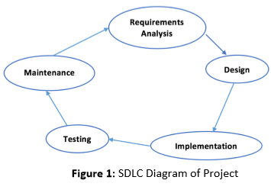

**Requirements**

**Project Requirement Specification**

By project requirements specifications we can analyze the tasks which going to be done by the system. The function and performance of allocated to software as part of system engineering are refined by establishing a complete information description. A detailed functional and behavioral description of the project and concentrating on requirements and constraints of that will provide and good product. The proposed system should follow these requirements:

* System must store information about users (Student and Teachers), tests, questions and result
* System should able the teacher to punch tests
* Each teacher should be able to punch many tests
* System should do not allow unauthorized user to enter the system
* Each student should be able to attempt many tests
* System should keep and display the results of Students
* System should support test which one or more question dependent on it
* System should allow the administrator to delete and update tests and questions dependent on it.

**Hardware Requirements**

|  |  |
| --- | --- |
| **Name of Component** | **Specification** |
| Computer System | RAM: GB  Processor: Intel dual core (64 bit) |
| Operating System | Windows 7 or above |

**Software Requirements**

* Python
* VS Code (Text Editor)
* Web Browser

**Implementation Constraints**

* **Design:** HTML CSS
* **Language:** Python
* **Database:** Sqlite

**Basic Concepts & Tools**

* **Python Introduction**

Python is a popular programming language. It was created by Guido van Rossum, and released in 1991. It is used for:

* web development (server-side),
* software development,
* mathematics,
* system scripting.

**What can Python do?**

* Python can be used on a server to create web applications.
* Python can be used alongside software to create workflows.
* Python can connect to database systems. It can also read and modify files.
* Python can be used to handle big data and perform complex mathematics.
* Python can be used for rapid prototyping, or for production-ready software development.

**Why Python?**

* Python works on different platforms (Windows, Mac, Linux, Raspberry Pi, etc).
* Python has a simple syntax similar to the English language.
* Python has syntax that allows developers to write programs with fewer lines than some other programming languages.
* Python runs on an interpreter system, meaning that code can be executed as soon as it is written. This means that prototyping can be very quick.
* Python can be treated in a procedural way, an object-oriented way or a functional way.

**Python Syntax compared to other programming languages**

* Python was designed for readability, and has some similarities to the English language with influence from mathematics.
* Python uses new lines to complete a command, as opposed to other programming languages which often use semicolons or parentheses.
* Python relies on indentation, using whitespace, to define scope; such as the scope of loops, functions and classes. Other programming languages often use curly-brackets for this purpose.
* **Django Introduction**
* Django is a Python framework that makes it easier to create web sites using Python.
* Django takes care of the difficult stuff so that you can concentrate on building your web applications.
* Django emphasizes reusability of components, also referred to as DRY (Don't Repeat Yourself), and comes with ready-to-use features like login system, database connection and CRUD operations (Create Read Update Delete).
* Django is especially helpful for database driven websites.

## How does Django Work?

Django follows the MVT design pattern (Model View Template).

* Model - The data you want to present, usually data from a database.
* View - A request handler that returns the relevant template and content - based on the request from the user.
* Template - A text file (like an HTML file) containing the layout of the web page, with logic on how to display the data.
* **VS Code**

Visual Studio Code for the Web is a browser-based version of the editor that can be used to edit both local files and remote repositories (on GitHub and Microsoft Azure) without installing the full program. It is officially supported and hosted by Microsoft and can be accessed at https://vscode.dev .

* **Sql Introduction**

SQL stands for Structured Query Language SQL lets you access and manipulate databases. SQL became a standard of the American National Standards Institute (ANSI) in 1986, and of the International Organization for Standardization (ISO) in 1987.

**What Can SQL do?**

* SQL can execute queries against a database
* SQL can retrieve data from a database
* SQL can insert records in a database
* SQL can update records in a database
* SQL can delete records from a database
* SQL can create new databases
* SQL can create new tables in a database
* SQL can create stored procedures in a database
* SQL can create views in a database
* SQL can set permissions on tables, procedures, and views
* SQL is a standard language for storing, manipulating and retrieving data in databases.

**Diagrams**

**Data Flow Diagram**

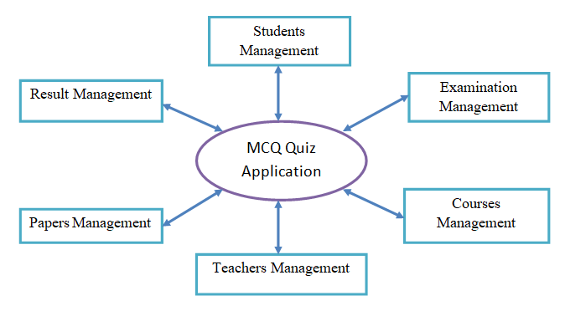

Fig – Data Flow Diagram

**Use Case Diagram**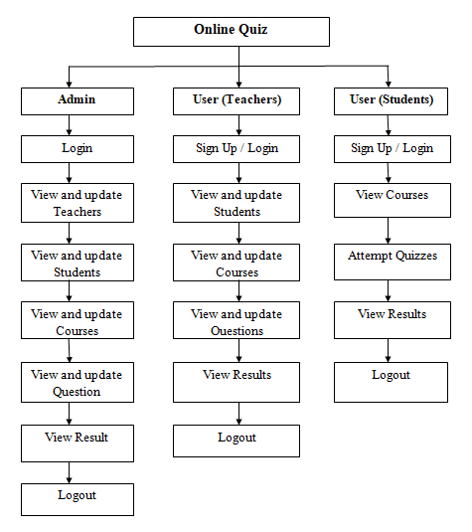

Fig – Use Case Diagram

**Modules of Project**

**Home Page** - This page is the welcoming page or the page where the user is redirected after logging in to the system. On this page also, quizzes summary can be seen.

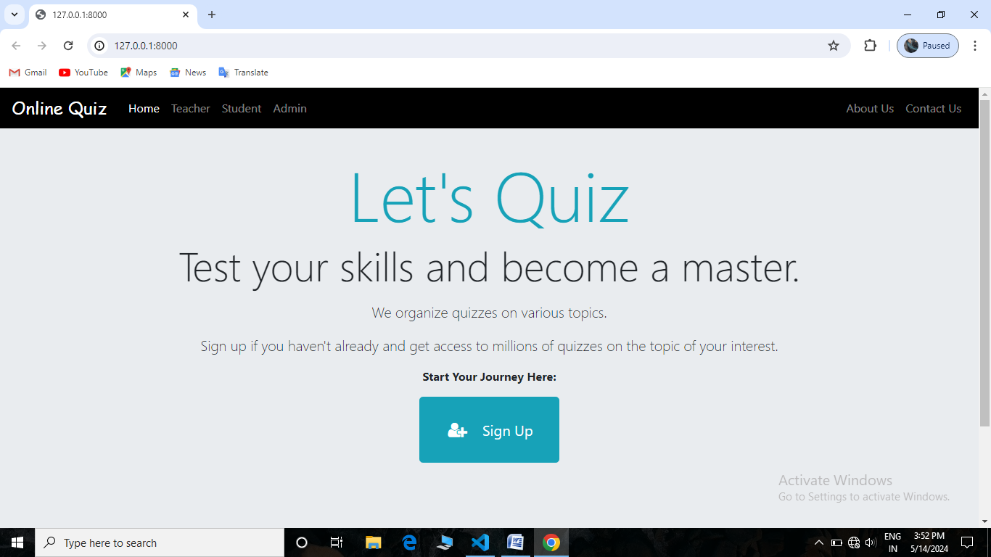

Fig – Home Pages

**Login Page** – This page helps to secure the project data and also helps to manage user’s access.

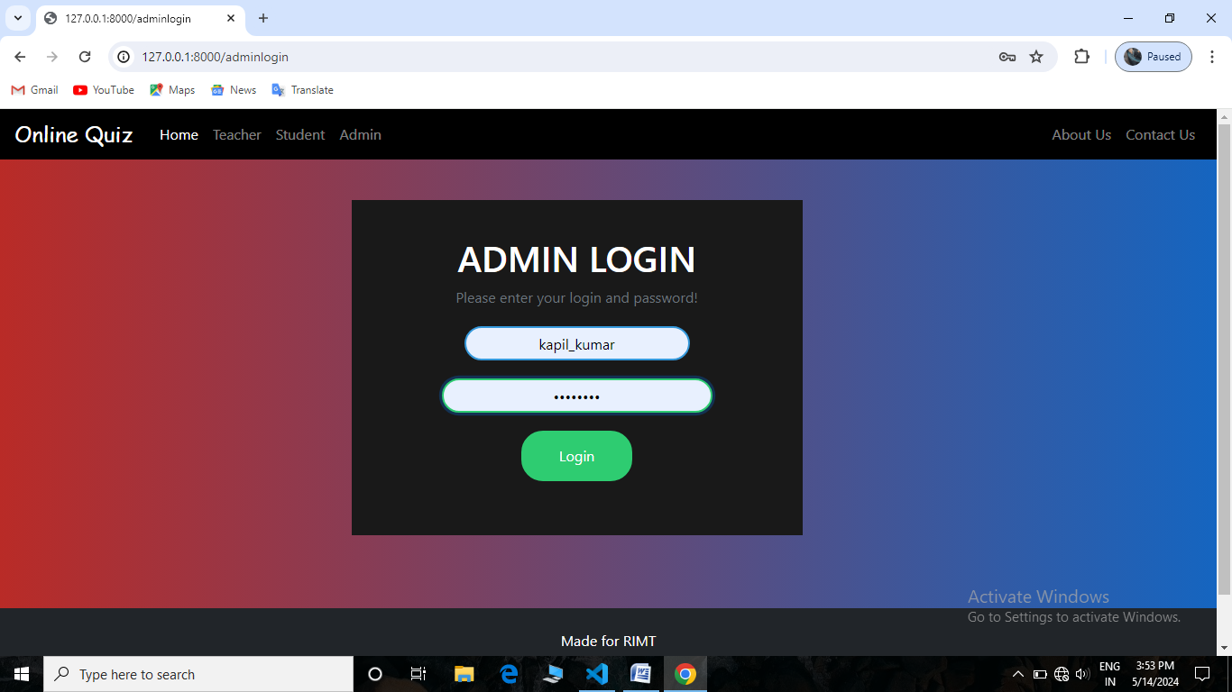

Fig - Login Page of Admin

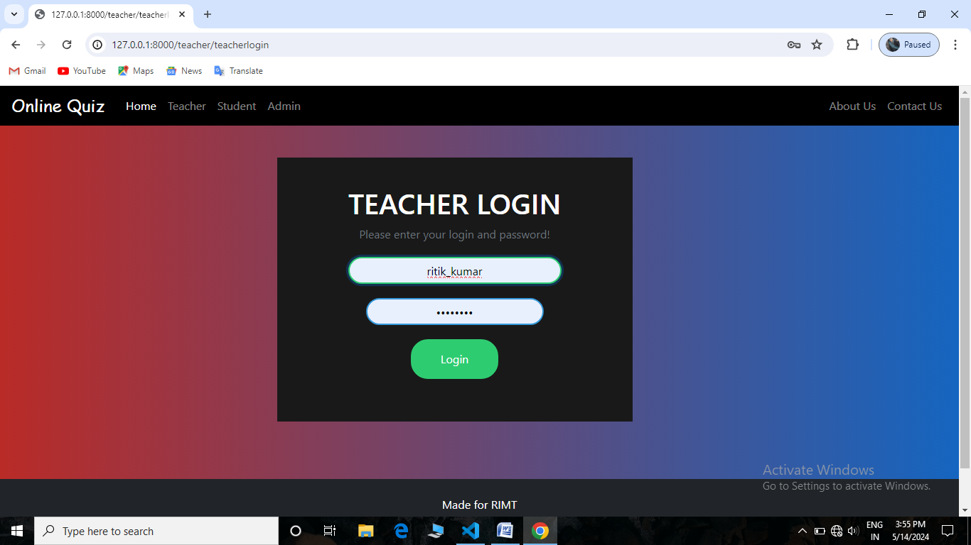

Fig - Login Page of Teacher

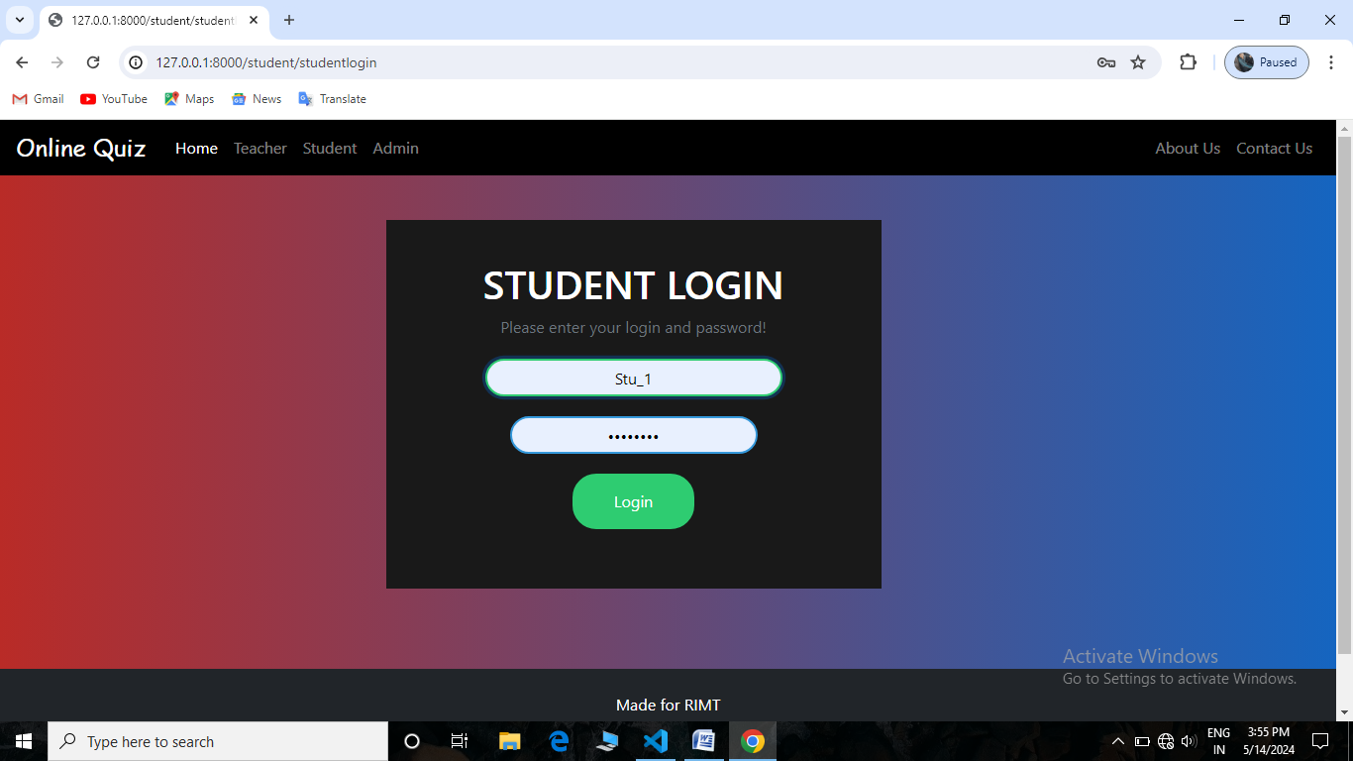

Fig - Login Page of Student

**Admin Dashboard** – On this page admin can manage the details of students and teachers and also the courses and exams.

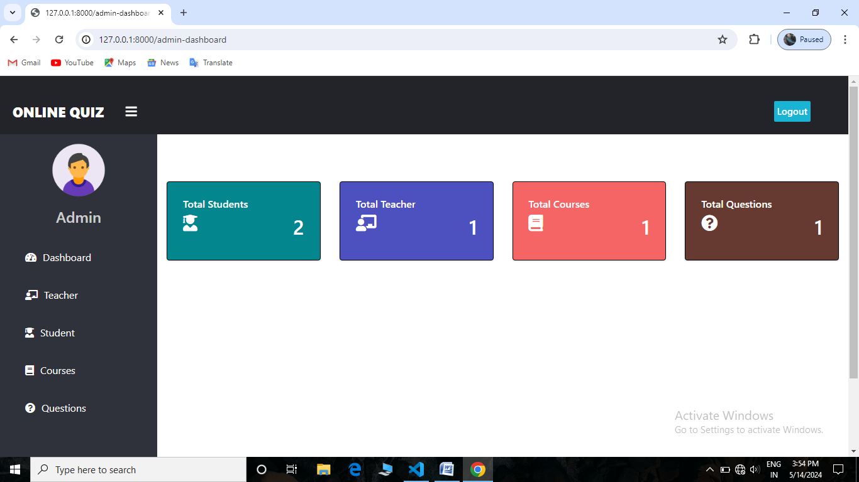

Fig – Admin Dashboard

**Teacher Dashboard –** On this page teacher can manage the details of students and courses and exams.

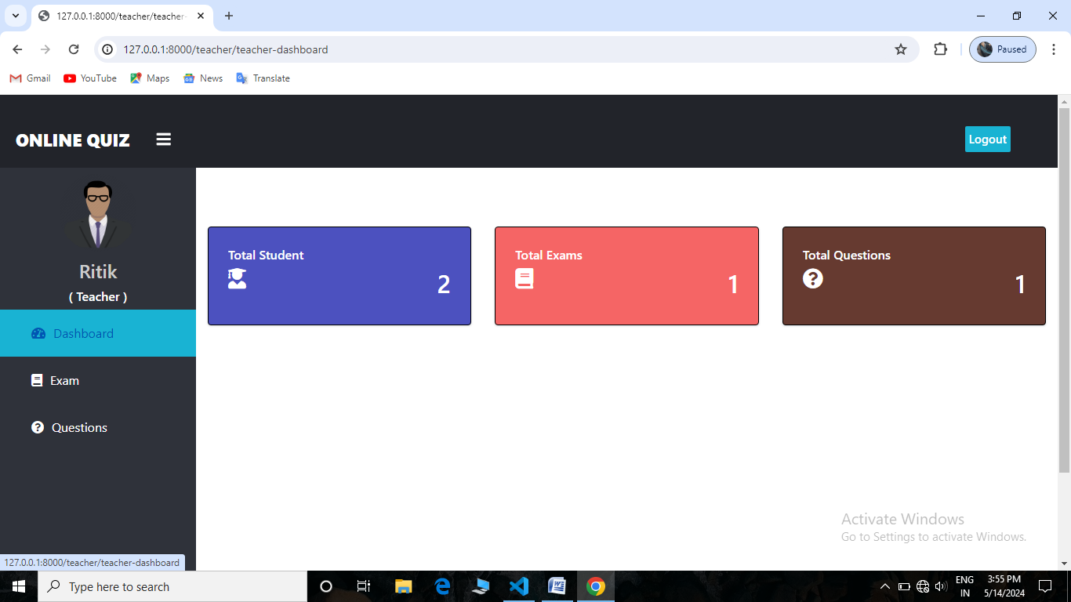

Fig – Teacher Dashboard

**Student Dashboard –** On this page student can manage the his/her details and can view courses and exams.

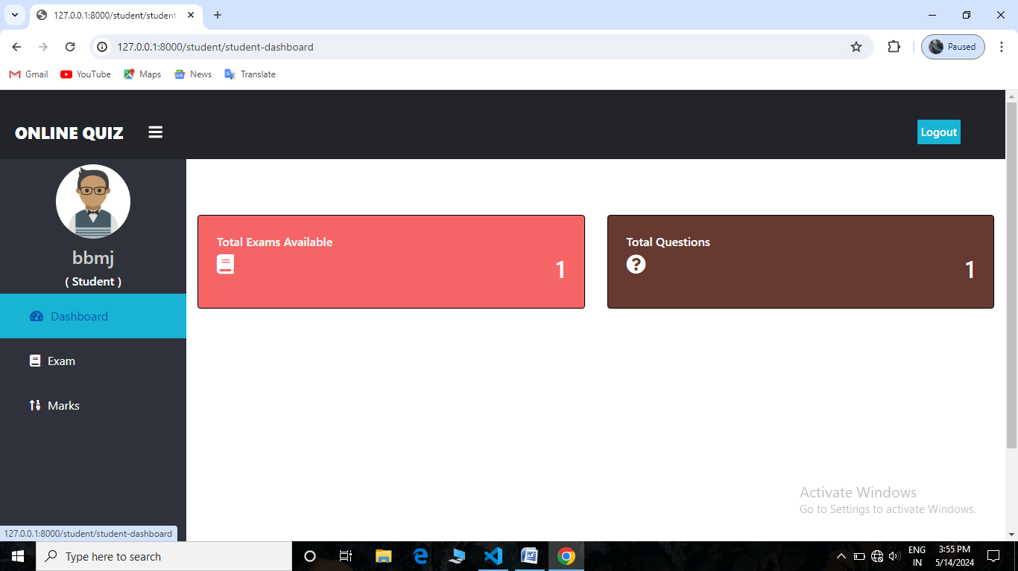

Fig – Student Dashboard

**Teacher Page** – Here admin can manage faculty details , can view and update the teachers

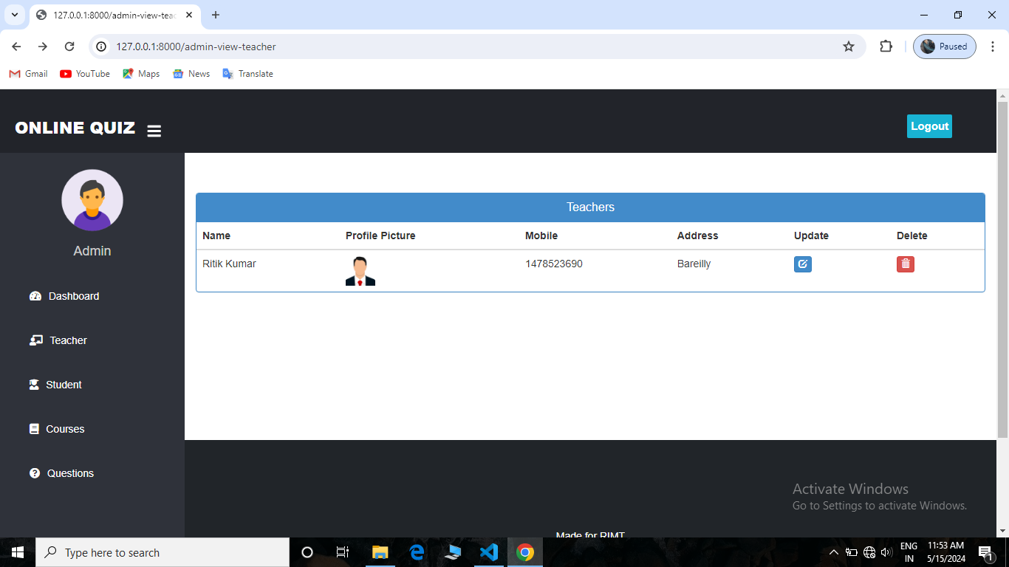

Fig – Teachers Page

**Student Page** – Here admin can manage student details , can view and update the students

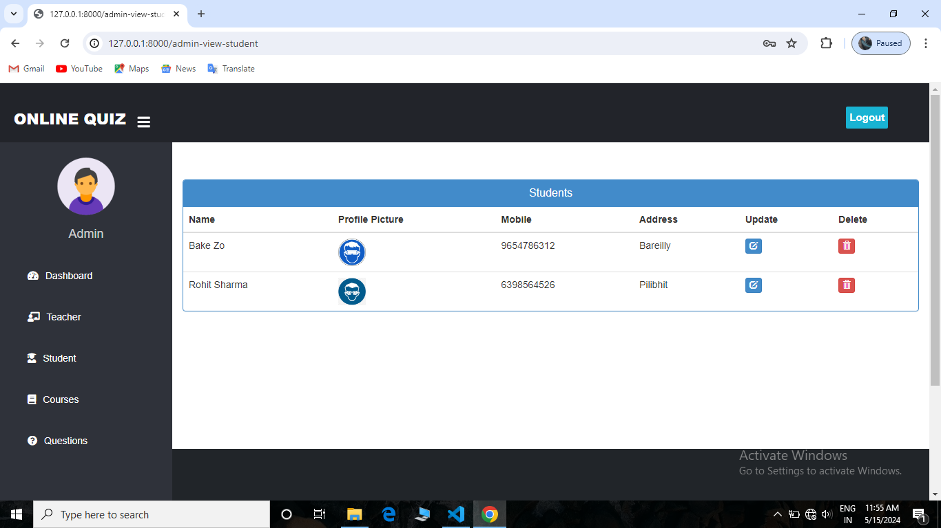

Fig – Students Page

**Courses Page** – On this page admin and teacher can manage courses and students can only view it.

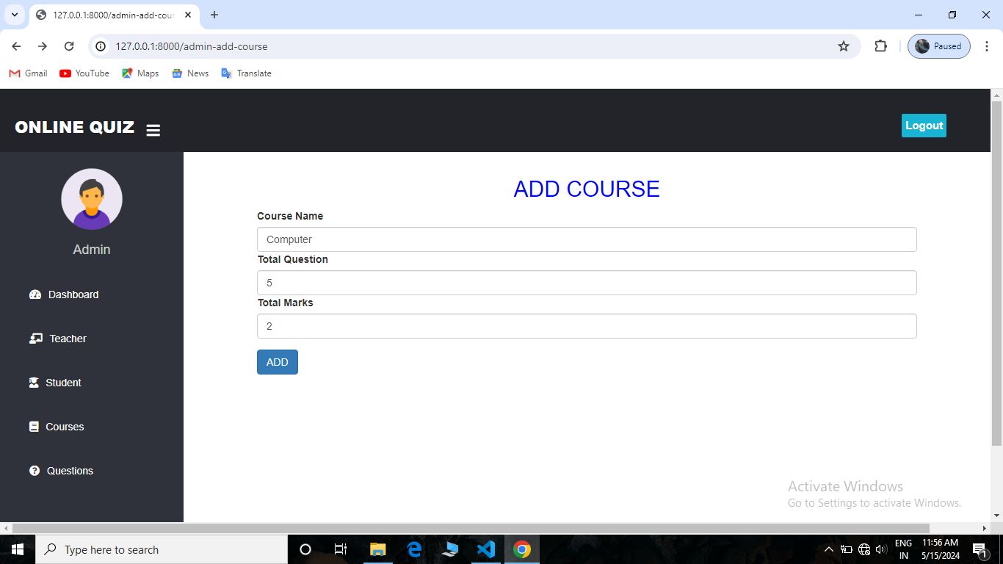

Fig – Add Course

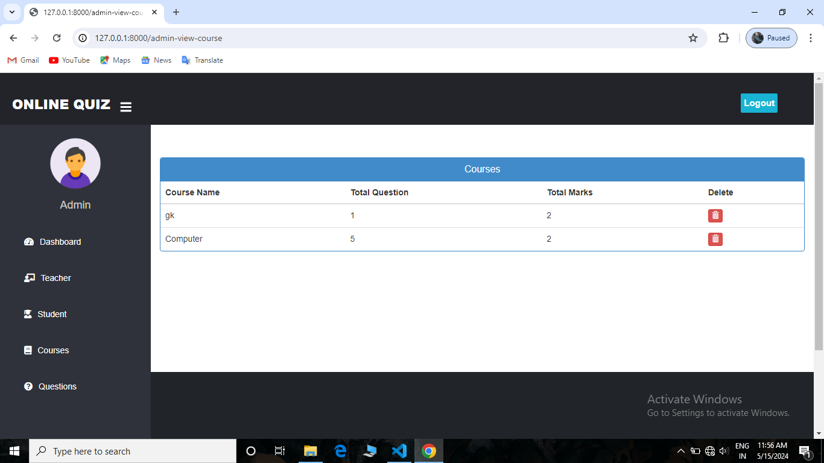

Fig - View Courses

**Exam page** - On this page admin and teacher can manage exams, add questions and students can only solve it.

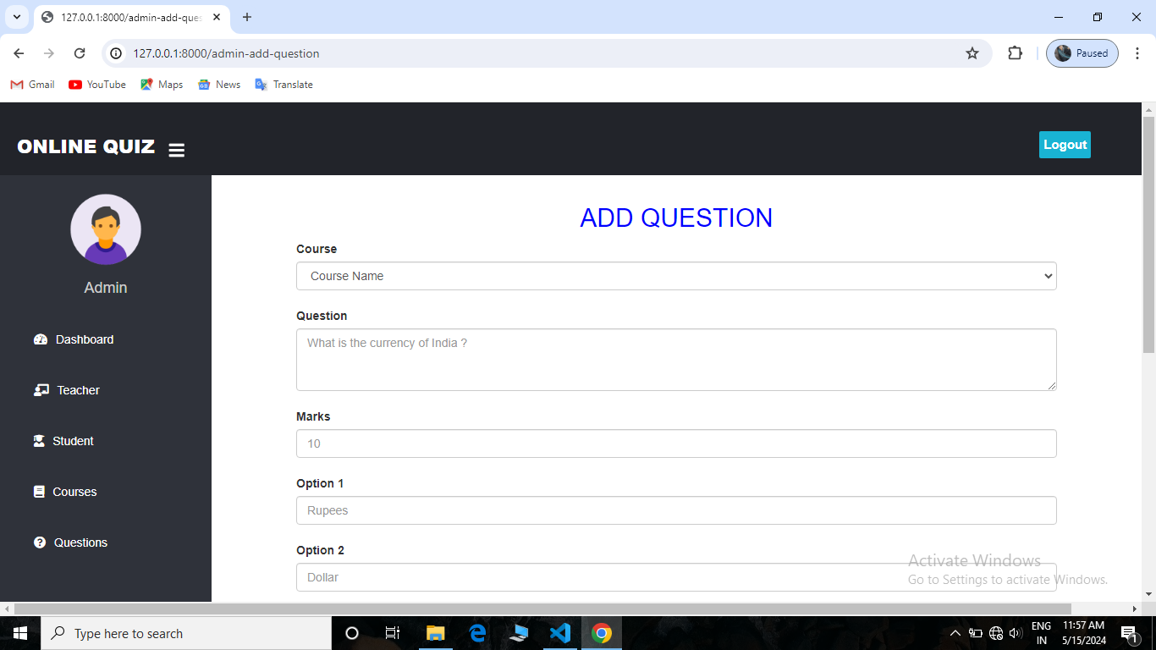

Fig – Add Questions

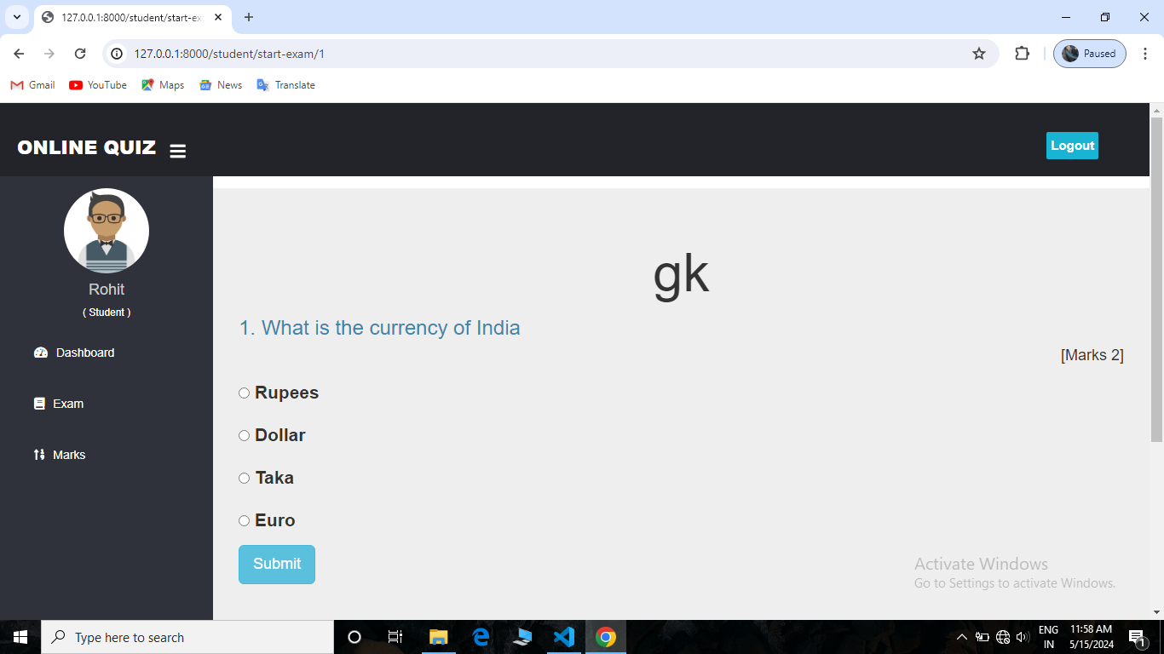

Fig – View Exam

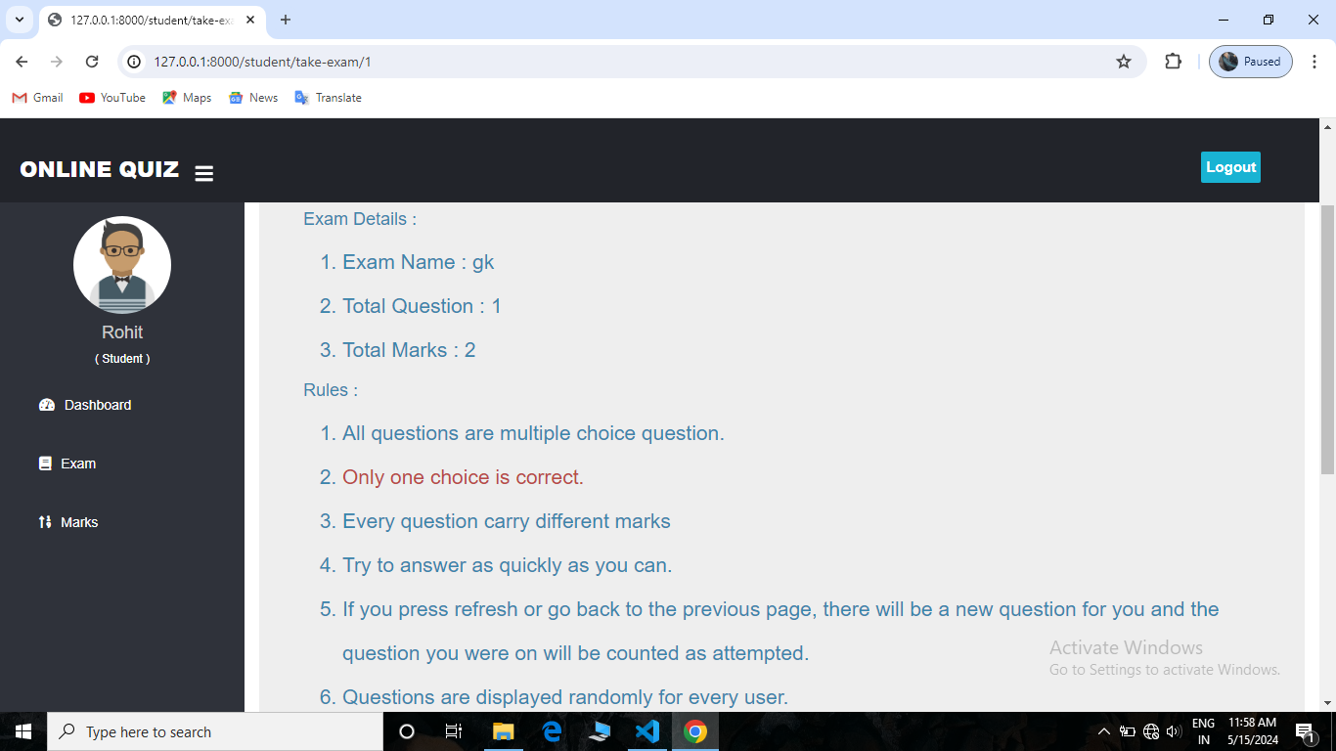

Fig – Rules of Exam

**Marks Page** – On this page admin, teacher can see the marks of the students and students can only see his/her marks.

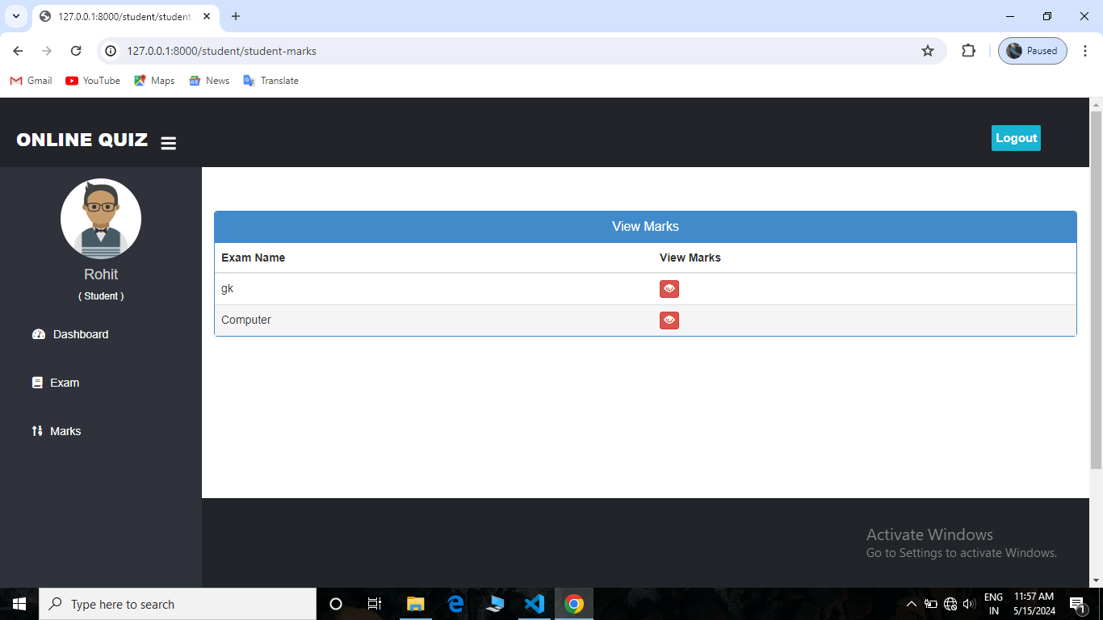

Fig – View Marks

**Logout Page** – This page will appear after the logout

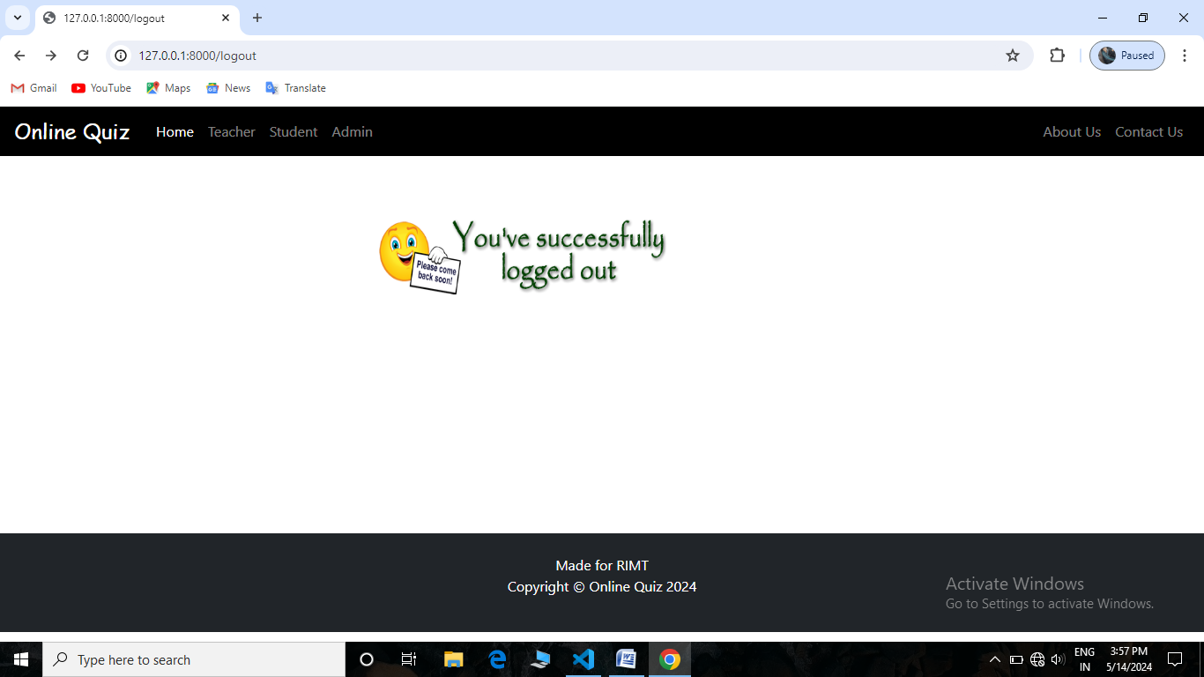

Fig – Logout Page

**Project Testing**

* **Objectives**

The objective our test plan is to find and report as many bugs as possible to improve the integrity of our program. Although exhaustive testing is not possible, we will exercise a broad range of tests to achieve our goal. We will also test the user friendliness of our app .The application will be used as an important tool, but we would like to ensure that it could be run on a variety of platforms with little impact on performance or usability.

* **Process Overview**

The following represents the overall low of the testing process:

1. Identify the requirements to be tested. All test cases shall be derived using the current Program Specification.
2. Identify which particular test(s) will be used to test each module.
3. Review the test data and test cases to ensure that the unit has been thoroughly verified and that the test data and test cases are adequate to verify proper operation of the unit.
4. Identify the expected results for each test.
5. Document the test case configuration, test data, and expected results.
6. Perform the test(s).
7. Document the test data, test cases, and test configuration used during the testing process. This information shall be submitted via the Unit/System Test Report (STR).
8. Successful unit testing is required before the unit is eligible for component integration/system testing.
9. Unsuccessful testing requires a Bug Report Form to be generated. This document shall describe the test case, the problem encountered, it's possible cause, and the sequence of events that led to the problem. It shall be used as a basis for later technical analysis
10. Test documents and reports shall be submitted. Any specifications to be reviewed, revised, or updated shall be handled immediately.

* **Testing Process**

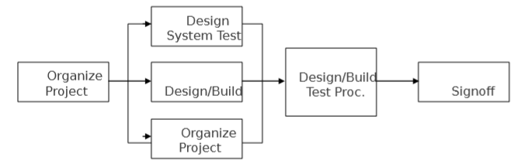

Fig – Test Process

The diagram above outlines the Test Process approach that will be followed.

* **Organize Project** involves creating a System Test Plan, Schedule & Test Approach, and assigning responsibilities.
* **Design/Build System Test** involves identifying Test Cycles, Test Cases, Entrance & Exit Criteria, Expected Results, etc. In general, test conditions/expected results will be identified by the Test Team in conjunction with the Development Team. The Test Team will then identify Test Cases and the Data required. The Test conditions are derived from the Program Specifications Document.
* **Design/Build Test Procedure**s includes setting up procedures such as Error Management systems and Status reporting.
* **Build Test Environment** includes requesting/building hardware, software and data setups.
* **Execute System Tests** identified in the Design/Build Test Procedures will be executed. All results will be documented and Bug Report Forms illed out and given to the Development Team as necessary.
* **Signoff** happens when all pre-defined exit criteria have been achieved.
* **Testing Strategy**

The following outlines the types of testing that will be done for unit, integration, and system testing. While it includes what will be tested, the specific use cases that determine how the testing is done will be detailed in the Test Design Document.

**User Manual**

This Manual will be order to get overall idea about the system is to be used. This manual will explain the need scope of a user manual as well as oline the suggested organization and content of user manual.

**Purpose:**

A user manual is prepared just before the implementation phase in the system development life cycle. The objective of the user manual is too clearly described and document the operating of the system for the user department in specific, non-ambiguous and non-technical terms

The ultimate test for any system is whether it can be used and efficiently and effectively or not. A system can not implement itself. It needs to people to start, use and maintain it, but they must learn how. Providing documentation that teaches how is the part of responsibility of every individual, as the member of the system team.

The need for user manual arises for the following reasons:

* The user manual represents the entry point into the system from the end user angle.
* The manual identifies the task which must be carried out by the user , in using the system, the objectives of these tasks is to maintain deliverables which signifies successful completion of each task.
* In many cases the manual is the sole means of learning how to work or how to correct errors.
* A comprehensive user manual describes in details all system inputs processor, outputs and control and provides background reading to supplement training and testing.

**The steps using this portal are as follows:**

1. The very first step for this portal is user-login.
2. The user is checked authentication.
3. Once the user is authenticated user, main screen appeared (dashboard).
4. He/she is able to access the desired page and makes manipulation with data.
5. The user can add in database.

**User manual for the developers:**

This manual will order to get overall idea about the system for the developers. This manual will explain how the system has been developed ? , which technologies are used for the development ? , which coding architecture is followed by the developers?

* Coding Architecture

3-tier architecture is used for the development of cooped.

Application Layer

Business Layer

Database Access Layer

* Technologies used

Python

Html

CSS

Sqlite for the database.

**Drawbacks and limitations**

* User must be computer literate
* If internet is not provide then can’t be worked

**Proposed Enhancements**

* This application avoids the manual work and the problems concern with it. It is an easy way to obtain the information regarding the different scheduled examinations information that are currently issued.
* We will make it more user friendly.
* The enhancement that we can add for the searching option. We can directly search to the particular details from this site.

**Conclusion**

The package was designed in such a way that future modifications can be done easily. The following conclusions can be deduced from the development of the project.

* Automation of the entire system improves the efficiency.
* It provides a friendly graphical user interface which proves to be better when compared to the existing system.
* It gives appropriate access to the authorized users depending on their permissions.
* It effectively overcomes the delay in communications.
* Updating of information becomes so easier.
* System security, data security and reliability are the striking features.

**References**

https://www.freeprojectz.com/premium-synopsis/synopsis-mcq-quiz-application <https://www.scribd.com/document/334841504/Synopsis-of-MCQ-Quiz-Applicatin>

<https://github.com/topics/quiz-app>

<https://www.wecschool/pythontutorial.com>

<https://www.stackoverflow.com>

<https://www.geeksforgeek/pythontutorial.com>

<https://www.javatpoint/pythontutorial.com>